**WEB & MOBILE PROGRAMMING**

**2019 / 2020 Semester 1**

**ASSIGNMENT**

Instructions and Guidelines:

1. Both Assignment 1 and Assignment 2 are individual assignments.
2. **Assignment 1** is to be handed in by **26 Jun 2022, 23:59.**

1. **Assignment 2** is to be handed in by **07 Aug 2022, 23:59.**
2. You are required to submit a soft copy of the project. The softcopy must contain source code and all required files i.e. images, javascript, css and html files. It can be submitted in the digital drop box for this module as a **zip** file. The name of the compressed file should be like “**pNNNNNNN.zip**” where NNNNNNN is your admission number.
3. The Assignment interview will be conducted during the session on the lesson after the submission date. No marks will be awarded if the work is copied or if you are absent from the presentation.
4. **5 marks will be deducted per working day late, up to a maximum deduction of 25 marks.**
5. **Assignment will NOT BE accepted after 12 Aug 2022 23:59, and 0 marks will be awarded for non-submission.**

# Assignment 1

# Form Data Validation

1. In your assignment, you need to create the “Add Song” form for the admin to add a new song into the system. The perspective of the assignment is to create an add product form for the web admin to add a new item to the database, the WMP Assignment 1 focuses on JavaScript and HTML to create such form.
2. The HTML file allows the user to provide data inside the respective textbox input controls. When the user clicks the Submit button control, the client-side JavaScript logic will begin inspecting all the textboxes to find out which textbox has empty data. You are to detect the textboxes that has empty data, and output messages to inform the user that the fields need to be entered with data.
3. Include a div element, divMessage into the web form. E.g.  
   <div id="divMessage"></div>
4. Proper help messages should be displayed in the div element, divMessage. For example, if the user provides no data input for Title and Type, the JavaScript will display messages **such as**:

* Title of Song is required.
* Genre of Song is required.

1. The client-side JavaScript should apply CSS style on the respective textboxes that has missing data or fail the validation criteria. For example, if the Name data is missing, the txtTitle control will be highlighted with a background color of yellow.
2. Note that, if the textbox has valid data, they should have a background colour of white.
3. Duration can only contain digits and optionally a decimal point(.) between the numbers with 2 decimal values and not exceeding .60, e.g. 2.10. The value represents minutes and seconds, with the whole number representing minutes and decimal values representing seconds.  
   You are to accomplish this without using regular expression.
4. Add client side JavaScript validation in this web form so that the following validation criteria is met and appropriate message is displayed in the div message box: Type must be a valid Genre Type during submission. E.g. Funk is valid, but City Hall is not. You should have a list of valid Product Types to verify against: **Classical, Funk, Rock, Pop**.
5. Update the number of characters typed so far in the “Description” textarea, as the user types.

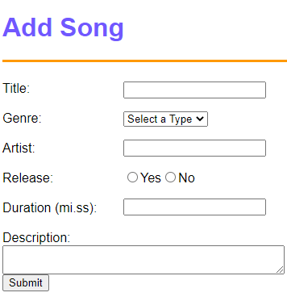

Assessment

The project will be assessed based on the following criteria:

1. Ability to demonstrate the required functionality for the project specification based on:

* Presentation and demonstration
* Explanation of the code in the HTML file.

1. Code implementation

* Appropriate usage of JavaScript and jQuery
* Code efficiency

1. Program readability

* Sufficient source code documentation
* Meaningful methods and identifiers

1. Implementation of advance features in javacript/jquery

* Creativity and effectiveness of advanced features.

End